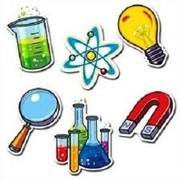
P5 Home Learning

Allocated 28th February-Due 23rd March

Our focus for this term is science.
We would like to hear/see/read and experience your individual research on famous scientists from around the world and any decade.
How you demonstrate your knowledge will be up to but you have to share your findings individually! These will be shared during the last week of term!
Examples could be:
- Using Book Creator
- Create a Jam Board
- Create slides
- Create a poster
- Make a leaflet
You will be sharing what you have found to small groups within the class who feedback to you using peer assessment strategies.
Here is a link to some ideas of famous scientists:
https://www.dkfindout.com/uk/science/famous-scientists/
What we will be expecting you to do is:
Who your famous scientist is and when they lived/did their discovery
Share their most famous scientific discovery
What impact their scientific discovery has had
Pictures to support what you are sharing
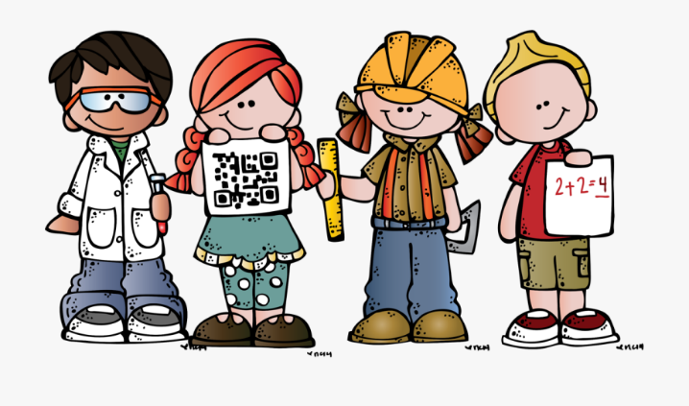
We can’t wait to see and hear about the wonderful research you do!

